How The Indicators Were Chosen
Beginning in 1994, researchers from McMaster University, the International Council for Local Environmental Initiatives (ICLEI), and staff developed an initial list of 60 indicators, along with a workbook community participants could use to evaluate the indicators. The following criteria were used: measurability, cost/ease of collection, credibility and validity, balance, and potential for effecting change.

The indicators have evolved since that time through community process in 1998, and sometimes through necessity. At times, data became unavailable and staff substituted a similar indicator in order to complete the report. The entire suite of indicators is being reviewed in a multi-stakeholder process in 2005.

The 2005 Indicator Review
As part of the current five-year review of VISION 2020 stakeholders will be looking at the Indicators Program for ways to improve the report: the use of new indicators, how we communicate with each other, and ways we use the information in the report.

Taking Action
The Indicators are community-based. The Report was designed to provide information that would motivate action on both a personal and policy level. The Regional Official Plan incorporated sustainable community policies and individuals and groups have undertaken activities and projects. Since amalgamation in 2001 Hamilton has been striving to create new ways to translate the Indicator Report information into action.

The VISION 2020 Annual Sustainability Indicators Report and Report Card are available at

www.vision2020.hamilton.ca

or by contacting

VISION 2020 Coordinator
(905)5456-2424 Ext. 1276

Copies are also available at City Hall, public libraries and Municipal Service Centers in Hamilton.

April, 2004


THE SUSTAINABILITY
INDICATORS
PROGRAM

In Hamilton, we have a vision
and we measure progress.

Our Vision
VISION 2020 is the vision of a strong, healthy sustainable city shared by citizens, City council, businesses and organizations. First adopted in 1992, VISION 2020 has been implemented, reviewed and renewed at five-year intervals ever since.

We know that to be sustainable, we need to consider the social/health, economic and environmental results of our decisions because a decision in one area will affect progress on other areas. We know that we have to think about long-term consequences and equity. We are committed to open and participatory government.

Measuring Progress
To help ensure that we’re headed in the right direction and to provide information that citizens and Council can evaluate, debate and act upon, the City of Hamilton Planning & Development Department publishes an Annual Sustainability Indicators Report and Report Card. The report provides a look at long-term social/health, economic and environmental trends that are influencing our community.

ANATOMY OF THE
INDICATORS REPORT

PURPOSE
The purpose of the report is stated on the inside front cover, “…to provide information to guide decision-making, and to generate debate and action to create a sustainable community.”

VISION
The pre-amble to the longer Vision statement is quoted on the first page of the report.

INTRODUCTION
This section provides a contextual overview of the VISION 2020 program and the role of Sustainability Indicators.

OVERALL PROGRESS
This is the holistic, big picture view of key factors that are influencing progress toward the Vision, including discussion on interactions, (how actions in one area may be having unintended outcomes in other areas), suggestions on what we can do differently, and identification of priorities for action.

CONTINUAL IMPROVEMENT
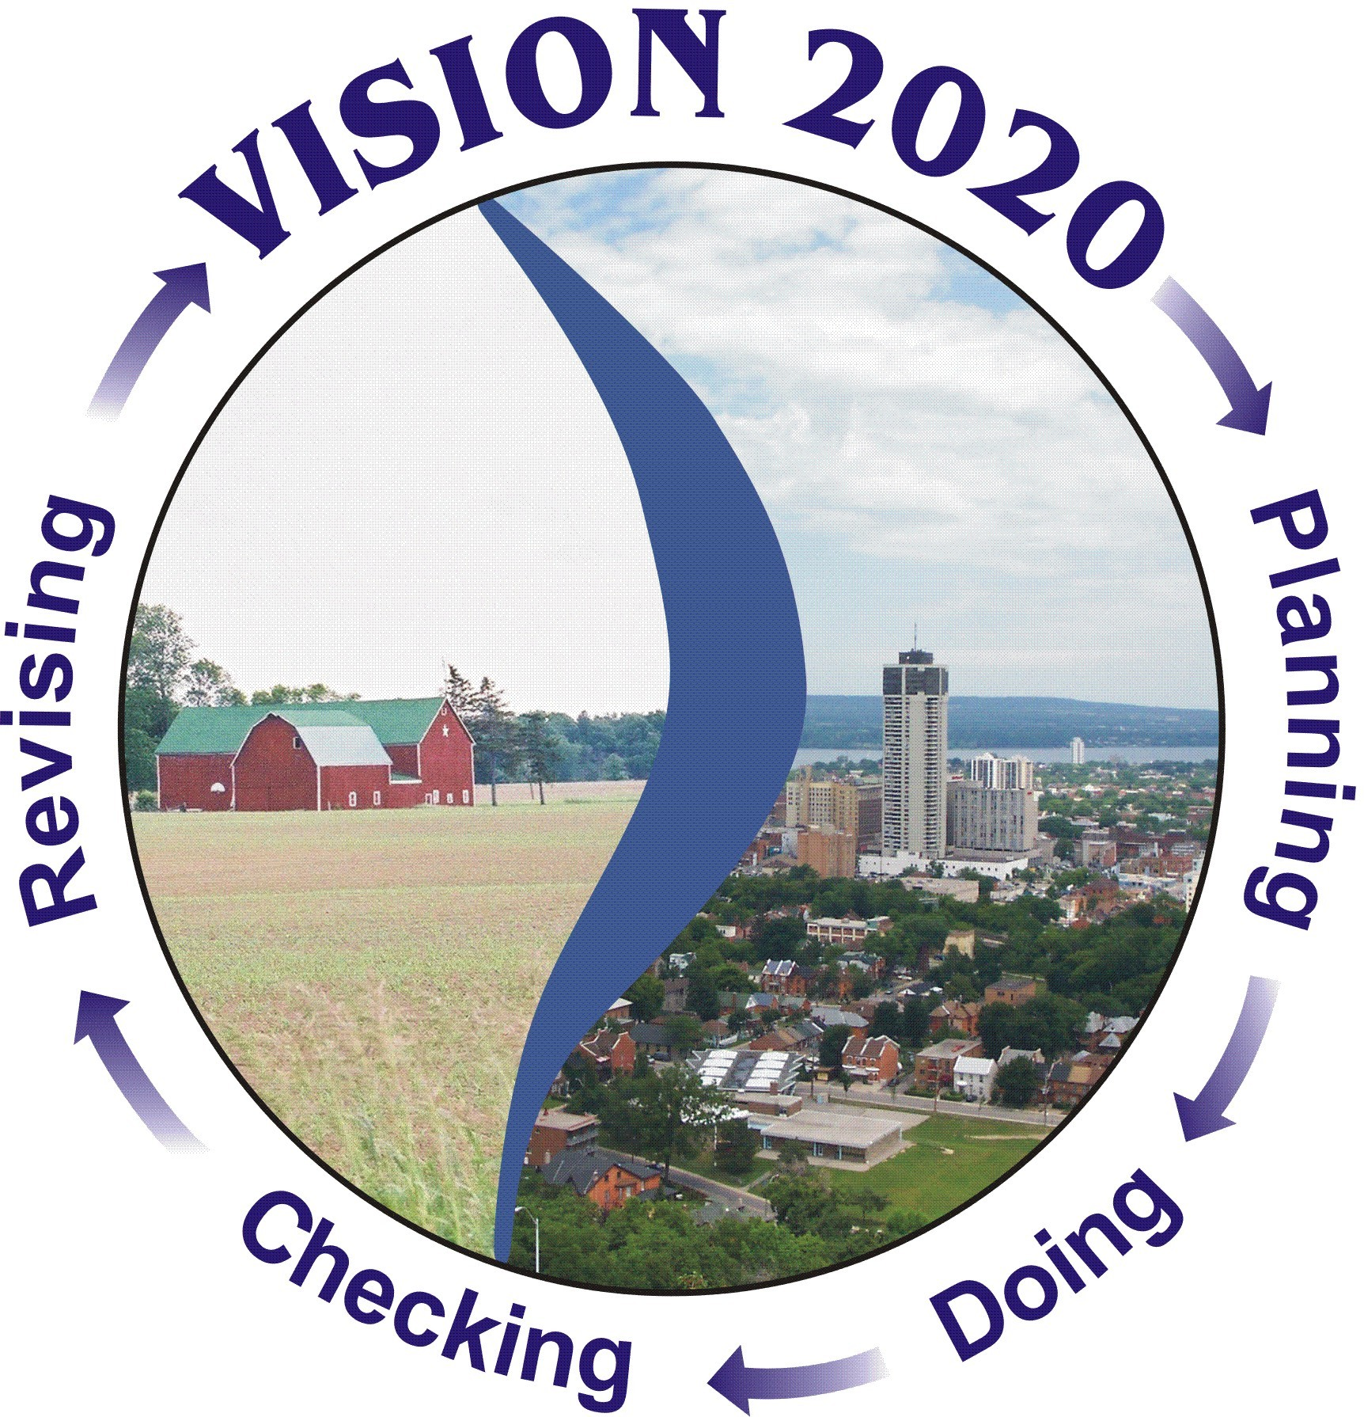The report contains a graphic depiction of VISION 2020’s “Plan Do Check Revise” cycle for continual improvement.

REPORT FORMAT
The body of the report is divided into the 14 Theme Areas of VISION 2020: Local Economy, Agriculture and the Rural Economy, Natural Areas and Corridors, Improving the Quality of Water Resources, Reducing and Managing Waste, Consuming Less Energy, Improving Air Quality, Climate Change, Changing Our Mode of Transportation, Land Use in the Urban Area, Arts and Heritage, Personal Health and Well-being, Safety and Security, Education, and Community Well-being and Capacity Building.

Each section begins with a Theme Area Overview which includes goals, a list of the indicators, community commentary, a list of places to get more information, and an interconnectivity web describing how performance in that area affects goals in other theme areas.

Each Indicator is presented with a description of the indicator, data in graphic and tabular form, the target, an evaluation of performance with an icon and text explanation, data provider comments, and indicator limitations. Data is obtained from local and provincial government and non-government organizations. Trends are measured against the 1992 benchmark figure. A “Did You Know” anecdote and a list of actions citizens, businesses and government can take to improve performance are also included.

The graphic icons were chosen from the outset to present the reader with an easily interpreted visual that could report on trends over time, toward or away from the target. Comments on the rate of change, factors affecting the trend and implications of continuing the trend are included in the analysis.

APPENDIX
The appendix consists of three elements:
“National Numbers”, excerpts from the Federation of Canadian Municipalities Quality of Life Reporting system that
compares Hamilton to other cities, a Bibliography of documents used in creating the Indicator Report, and a summarized list of all of the VISION 2020 Goals.

MEASURING THE
MEASUREMENT SYSTEM
An annual survey that can be completed and mailed in is included in the report. The survey can also be completed on-line. During the five-year review of the program, data provider interviews are held, a peer review is conducted and a variety of community engagement venues will be undertaken.

USING THE INDICATORS REPORT
The Indicators were originally presented at the “Annual Sustainability Day” each fall. A single day of evaluation did not achieve the original purpose of having the indicator results motivate action, nor did it substantially embed the information into the City’s decision-making processes. As we look back over what we’ve learned, we see that we still need an ongoing link between the information in the Indicators Report and the City budget, policies and operations. At the community level, discussion occurs at workshops on an ad hoc basis. Awareness of the Report and the Report Card has diminished. Our challenge is to make these links, raise awareness and coordinate efforts to achieve the goals in VISION 2020.

Municipal restructuring has provided the opportunity to build the Indicator results into major strategic planning exercises and most recently, Council directed that a “proactive link be established” between the Indicator Report results and the 2005 municipal budget process. More structured interventions into municipal and external organizational systems need to continue.
.

